**TERRAFORM TASKS (DAY- 04)**

1. **Watch terraform-04 video.**

Watching complete video and notes writing completed.

1. **Execute the script shown in video.**

**Version=”2.3.0” >> downloads the mentioned version**

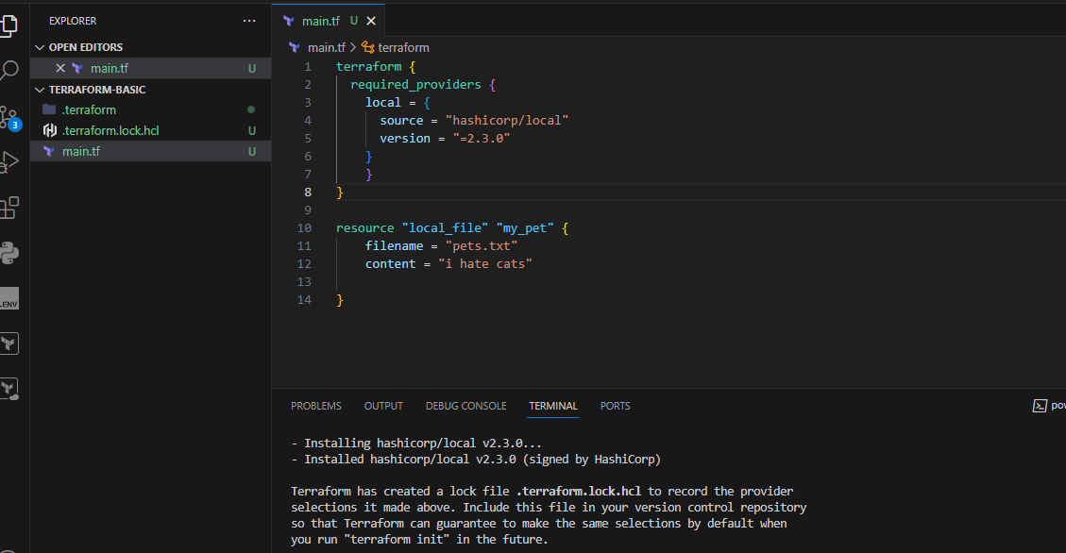

**“!=2.3.0” >> will not use the mentioned version**

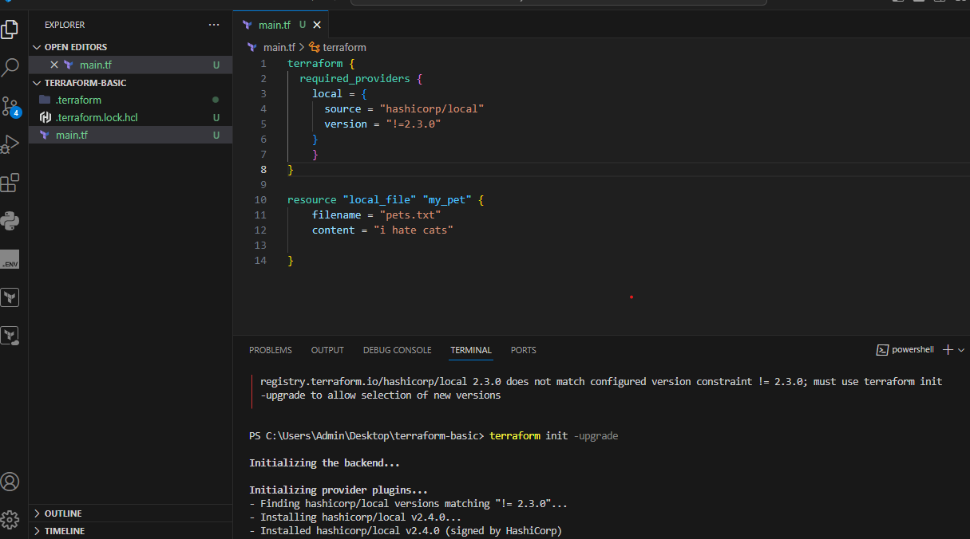

**Version = “>2.3.0” >> greater than the mentioned version**

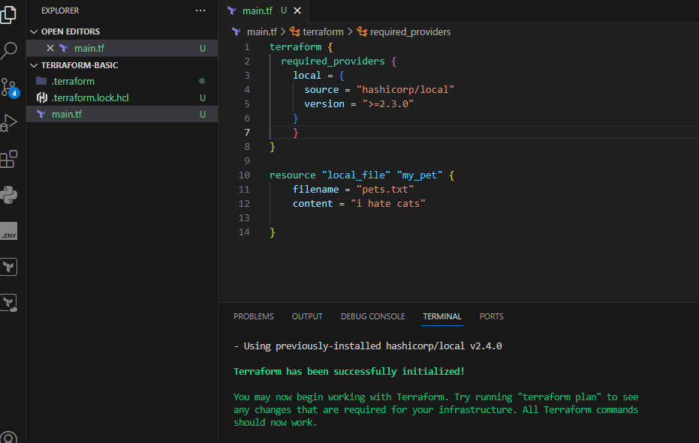

**Version = “~2.3.0”specific version or higher version**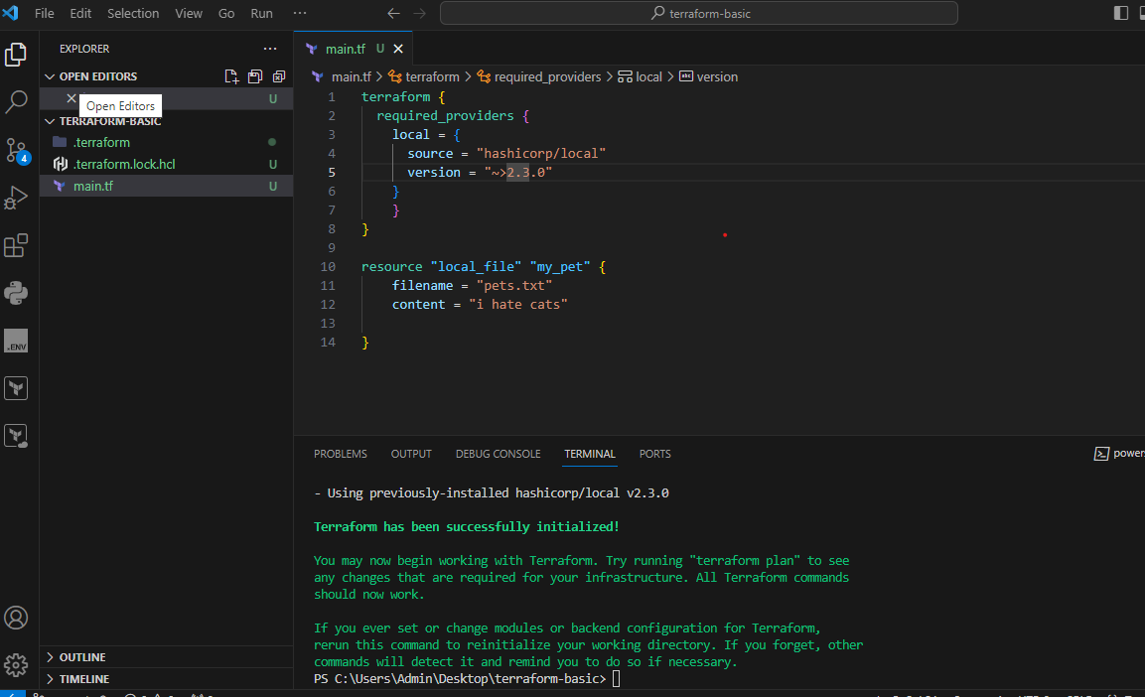

**Data sources:**

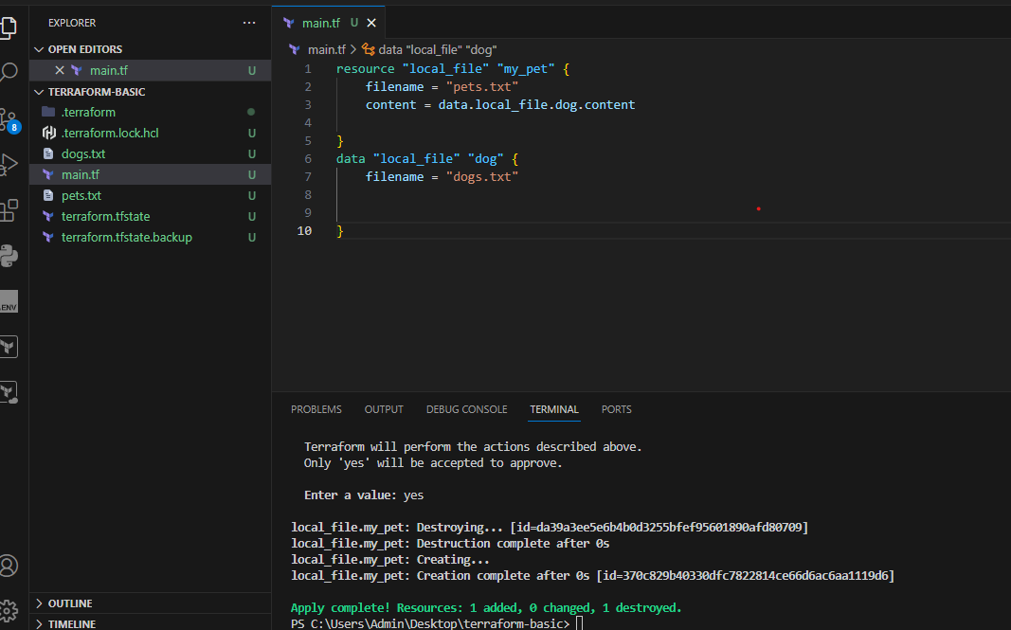

**Content in the dogs.txt file**

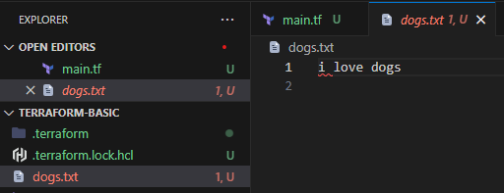

**Content in pets.txt is replaced with dogs.txt**

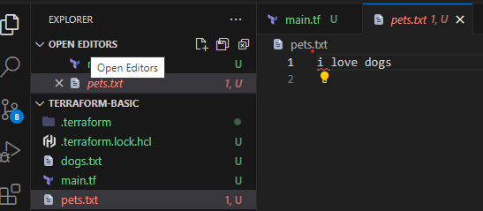

**Meta arguments:**

**Count**

**Created 3 files by using count meta argument:**

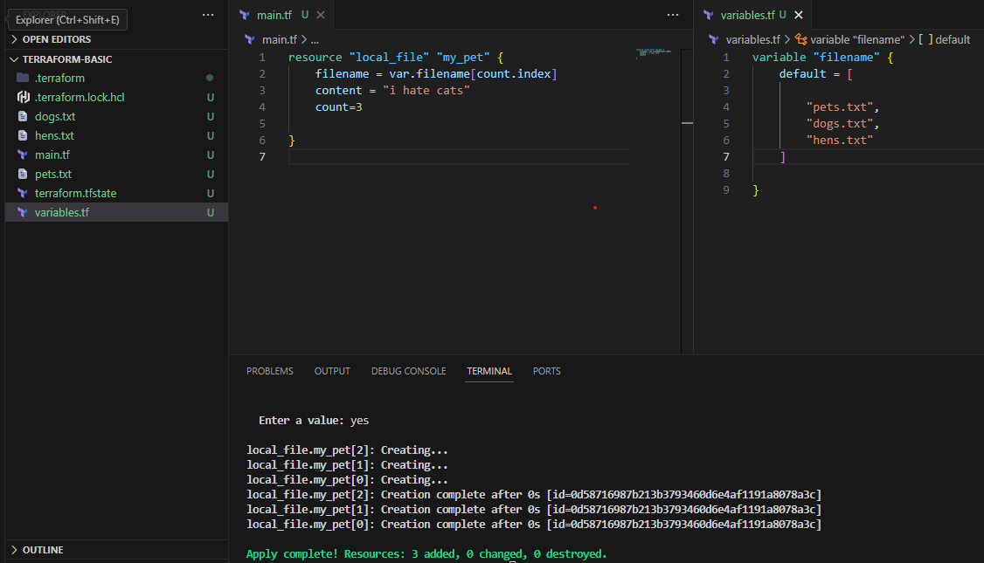

**Length(var.filenmae)**

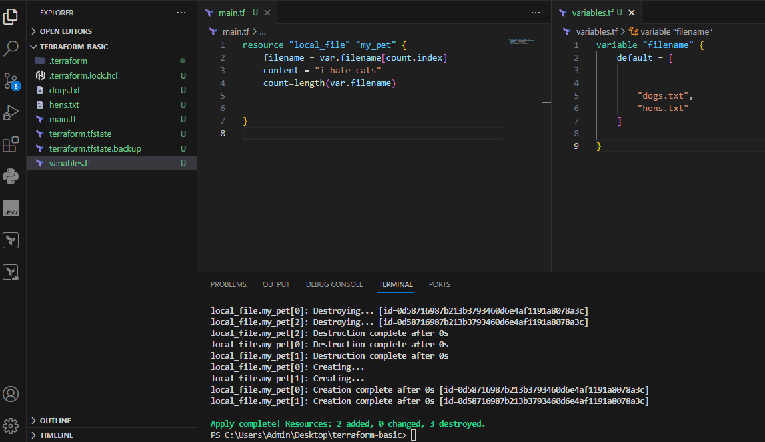

**For_each**

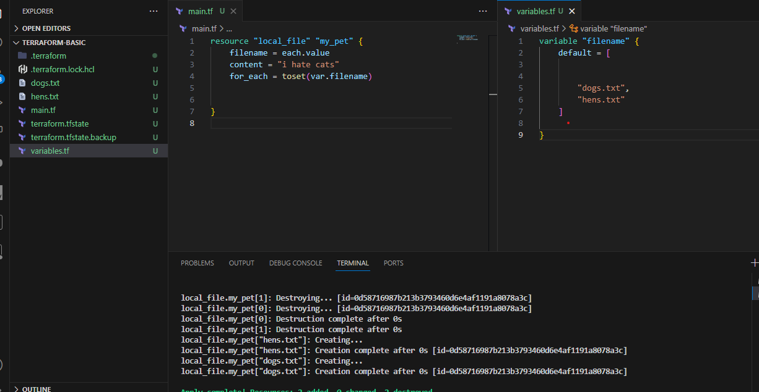

1. **Integrate terrafrom in jenkins using Terraform plugin.**
2. **Create CICD pipeline for Nodejs Application.**

[**https://github.com/betawins/Trading-UI.git**](https://github.com/betawins/Trading-UI.git)

1. **Explain 10 Maven commands.**